4.Capabilities
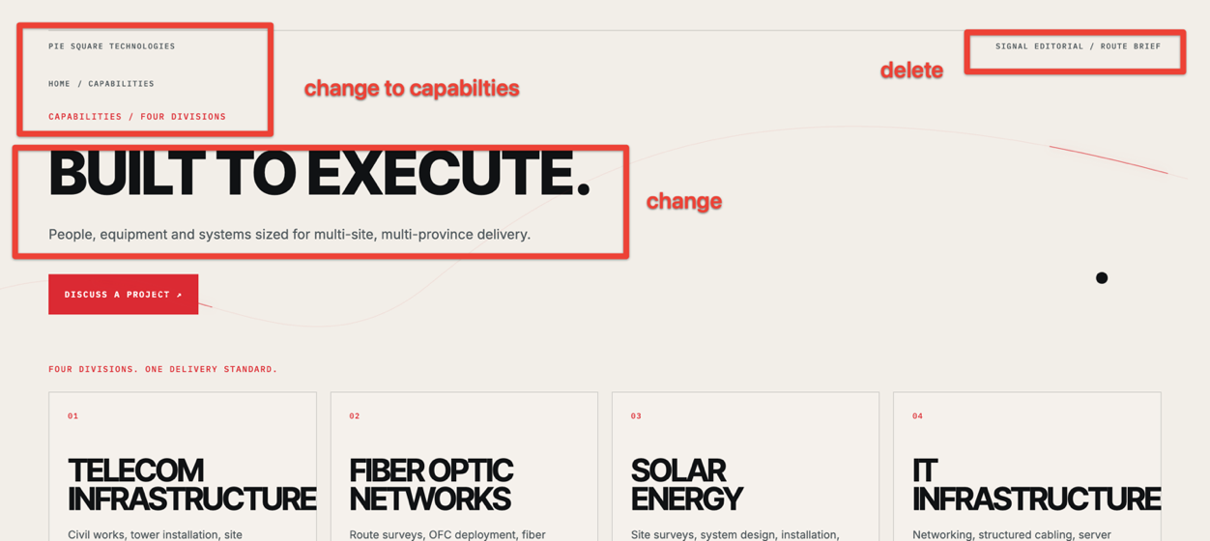
Built to Execute.
People, equipment and systems organized for multi-site, multi-location project delivery.
1.Keep experience at first in your existing style -
PROVEN DELIVERY
3,500+
RF SITES TESTED
SSV & Cluster Drive Testing
115
TELECOM SITES INSTALLED
Equipment Installation & Commissioning
4
NEW TELECOM TOWER SITES
Foundation · Erection · Power · Grounding · Fencing
2,240+ KM
FIBER NETWORK DELIVERY
Installation · Survey · Managed Services & LMC

400 kW
SOLAR O&M UNDER MANAGEMENT
Annual Maintenance & Operations

2.Then keep 4 capabilities in your existing style
FOUR DIVISIONS. ONE DELIVERY STANDARD.
01 — TELECOM INFRASTRUCTURE
Civil works · Tower installation · Equipment deployment · RF testing · Commissioning · Maintenance

02 — FIBER OPTIC NETWORKS
Route survey · OFC installation · Splicing · Testing · Fault restoration · Network maintenance

03 — SOLAR & ELECTRICAL
Solar PV · System design · Installation · Battery integration · Transformer installation · Electrical works · O&M

04 — IT SOLUTIONS
Network infrastructure · LAN/WAN · Structured cabling · Server systems · Wi-Fi · CCTV · IT support

TECHNICAL WORKFORCE

Trained. Certified. Field-Ready
Civil Engineers · Telecom Engineers & Technicians · RF Engineers· Fiber Technicians · Solar & Electrical Technicians · IT Professionals · Project Coordinators & Supervisors · Safety & Quality Personnel
Take this pic as sample.
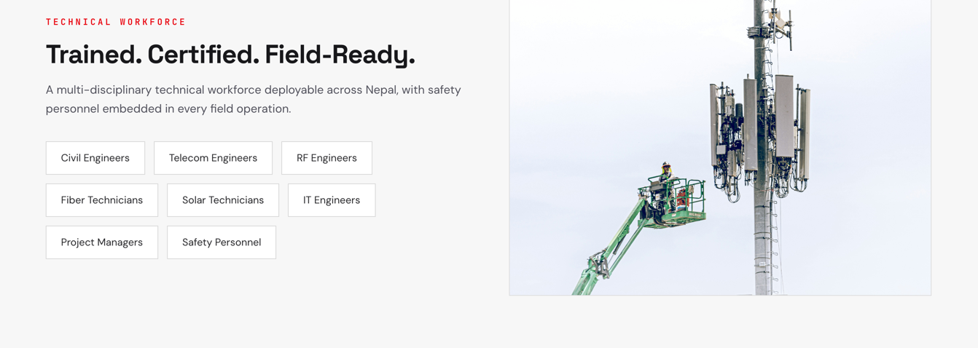

Add the following to the end
DELIVERY CAPABILITIES
PROJECT EXECUTION
Site deployment · Installation · Commissioning · Handover
FIELD ENGINEERING
Survey · Technical assessment · Supervision · Coordination
TESTING & COMMISSIONING
RF · Fiber · Electrical · System testing
OPERATION & MAINTENANCE
Preventive maintenance · Fault response · Restoration
PROJECT DOCUMENTATION
BOQ · Reports · Test records · As-built documentation · Handover
MULTI-SITE COORDINATION
Planning · Field deployment · Progress monitoring · Reporting

Take this as sample, but keep it 3*2
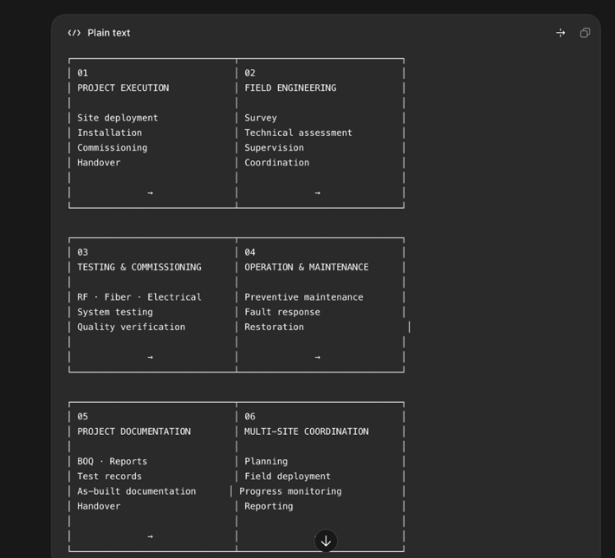

6.Certifications
Remove this heading. Not required

